Linux access from Active Directory

**Users**

root

**DNS**

Make sure Linux machine can access AD-Domain

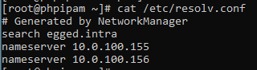

**Install**

yum install sssd realmd oddjob oddjob-mkhomedir adcli samba-common samba-common-tools krb5-workstation openldap-clients policycoreutils-python

**Connect realmd to AD**

1. test to see if realm can see the AD Domain

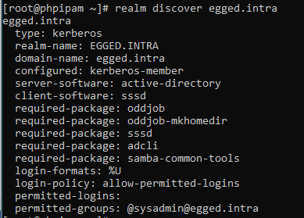

1. Connect realmd to egged.intra Domain



1. List realm

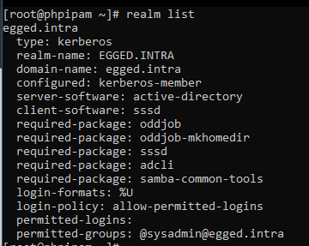

1. Test AD users, you should be able to see users from the AD Domain



* 1. This will create /etc/sssd/sssd.conf file…

**Restrict access to relevant Group**

Alter the file /etc/sssd/sssd.conf to look like this:

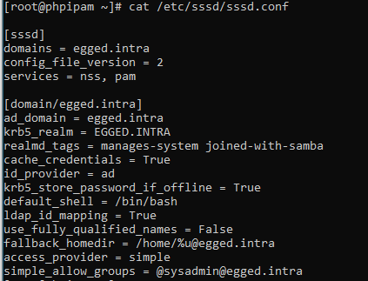

1. use_fully_qualified_names = False
   1. Lets you connect with username without “@domain”
2. access_provider = simple
   1. Instead of “ad”
   2. And then add the next line:
3. simple_allow_groups = @sysadmin@egged.intra
   1. @GROUP@DOMAIN